PRAS Accounts Receivable Setup
TORICO Code
Manual (R12)

Client:
Finance and Accounting Department

Author: Patricia Luna
Creation Date: October 3, 2018
Last Updated: October 3, 2018
Last Updated by: Patricia Luna
Control Number and Version are marked by a Word Bookmark so that they can be easily reproduced in the header and footer of documents. When you change either of these values, be careful not to accidentally delete the bookmark. You can make bookmarks visible by selecting Tools->Options…View and checking the Bookmarks option in the Show region.

- PROCEDURE DETAILS

  - Log in into Oracle Application 11i using your Username and Password
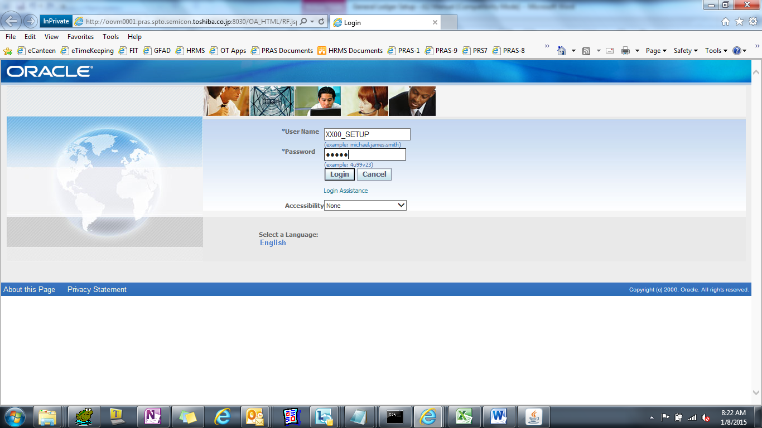
  - Select TIP ISD Helpdesk User responsibility

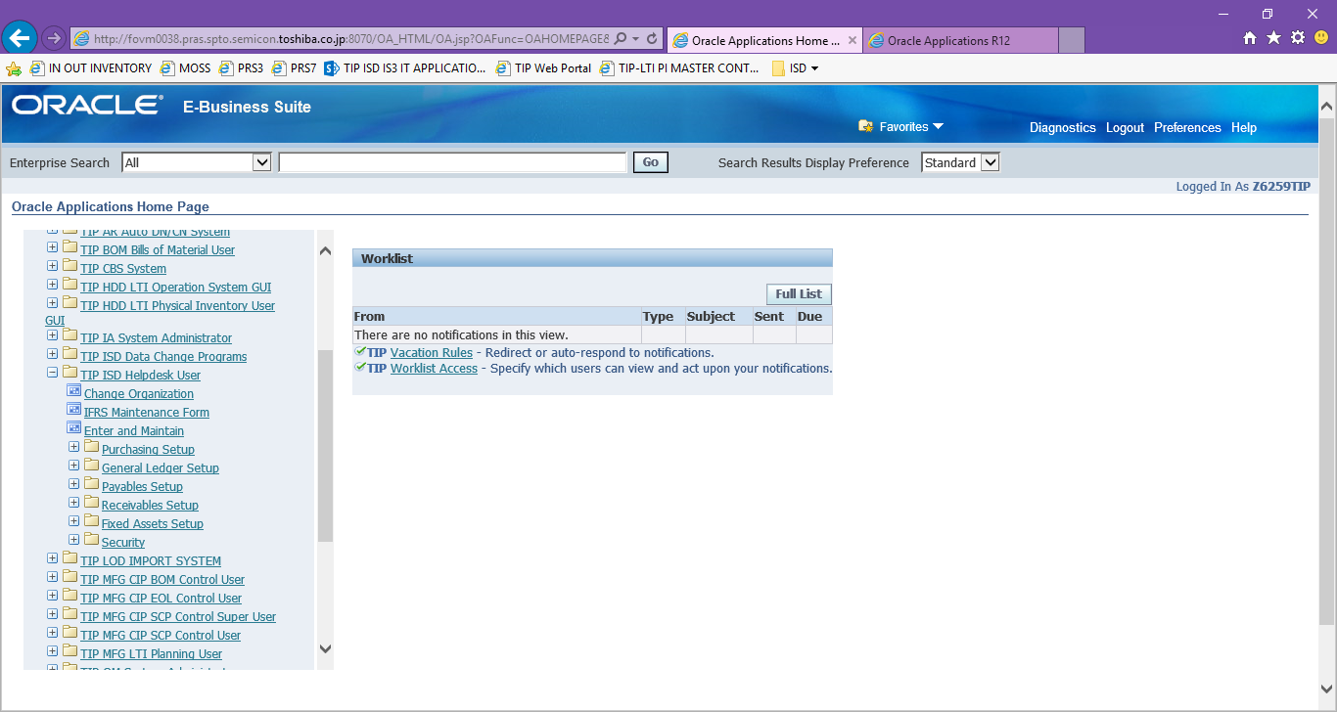

SHIP TO NAME Setup
  - Select IFRS Maintenance Form then click NEW (or FIND)
APPLICATION MODULE : AR
ENTITY NAME : AR_ORIG_SYSTEM_SHIP_CUSTOMER_NAME
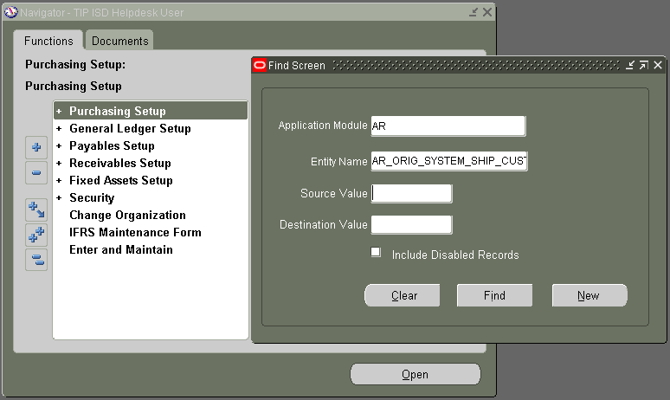

  - Define new TORICO code for Ship-to name.
SOURCE VALUE = Ship to code
DESTINATION VALUE = 7-digit TORICO code
START DATA = SYSDATE
ENABLED FLAG = Check to enable
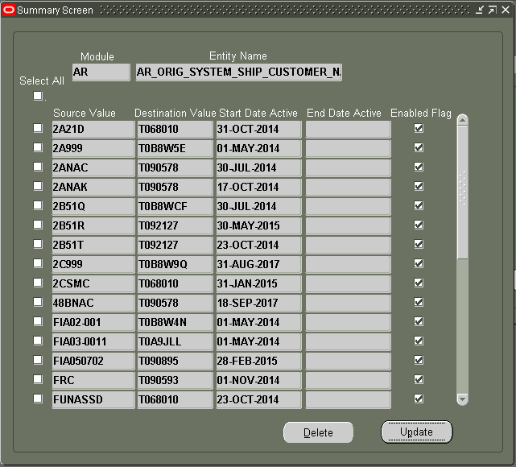
SHIP TO ADDRESS Setup
  - Select IFRS Maintenance Form then click NEW (or FIND)
APPLICATION MODULE : AR
ENTITY NAME : AR_ORIG_SYSTEM_SHIP_ADDRESS_NAME
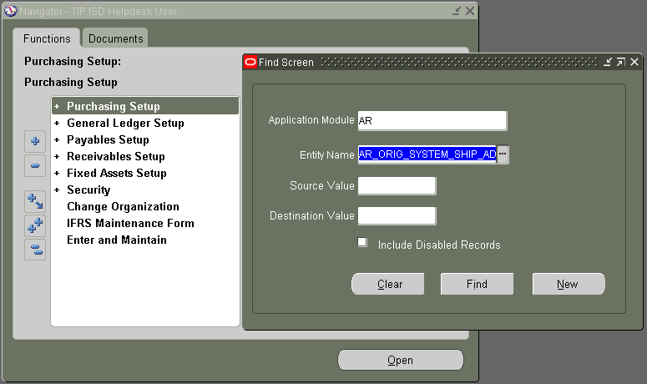

  - Define new TORICO code for Ship-to Address.
SOURCE VALUE = Ship to code
DESTINATION VALUE = 11-digit TORICO code
START DATA = SYSDATE
ENABLED FLAG = Check to enable
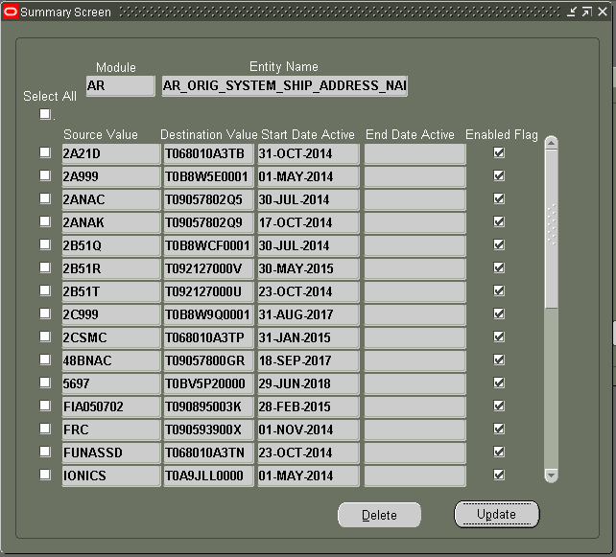
BILL TO NAME Setup
  - Select IFRS Maintenance Form then click NEW (or FIND)
APPLICATION MODULE : AR
ENTITY NAME : AR_ORIG_SYSTEM_BILL_CUSTOMER_REF
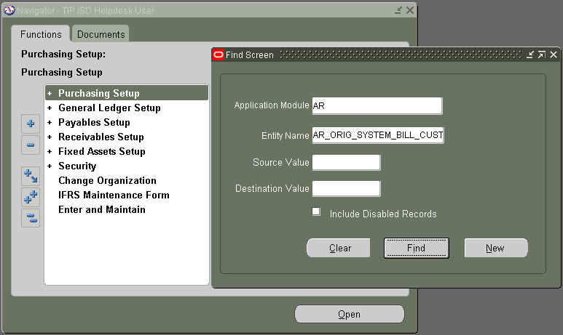

  - Define new TORICO code for Bill-to Name.
SOURCE VALUE = Bill to code
DESTINATION VALUE = 7-digit TORICO code
START DATA = SYSDATE
ENABLED FLAG = Check to enable
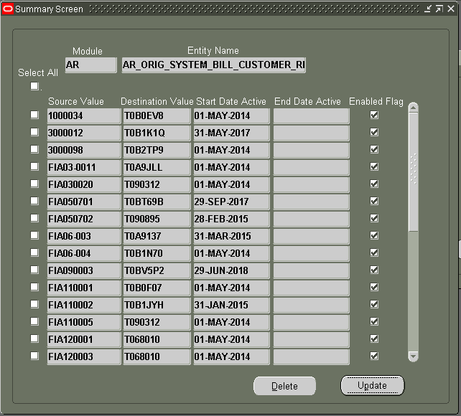
BILL TO ADDRESS Setup
  - Select IFRS Maintenance Form then click NEW (or FIND)
APPLICATION MODULE : AR
ENTITY NAME : AR_ORIG_SYSTEM_BILL_ADDRESS_REF
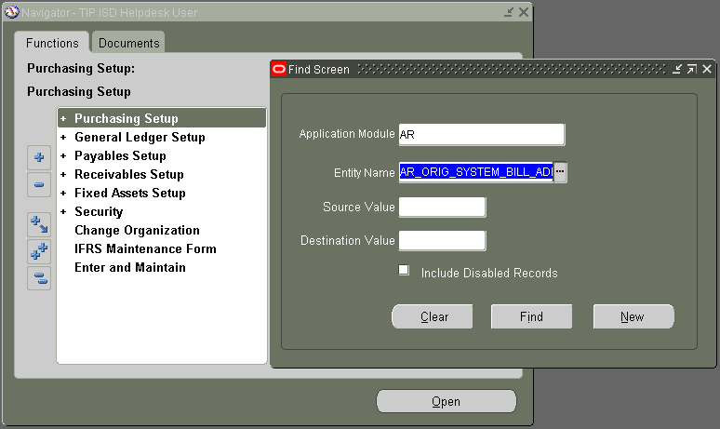

  - Define new TORICO code for Bill-to Address.
SOURCE VALUE = Bill to code
DESTINATION VALUE = 11-digit TORICO code
START DATA = SYSDATE
ENABLED FLAG = Check to enable
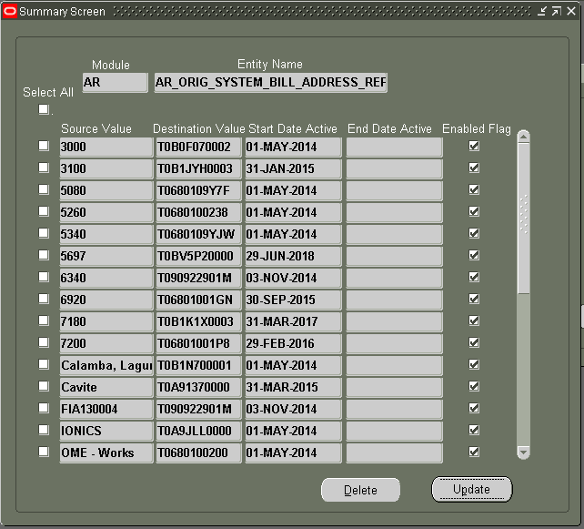
**Reference Table: XX00IFCMN_CODE_CONV_MASTER_ALL

